The objective of this assignment is to create an application to simulate the Mortgage Calculator as below utilizing many of the GUI components (javax.swing and java.awt). For this part of the lab, create a program which outputs a layout of the Mortgage calculator window as below:

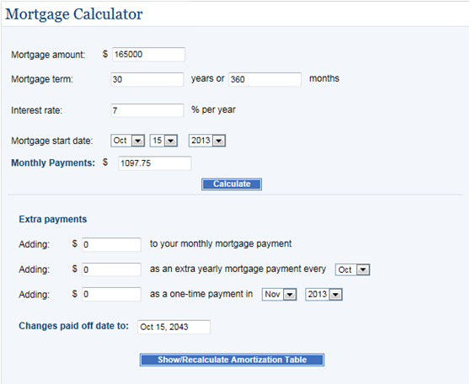

Ref: <http://www.bankrate.com>